Independent Software Vendors HTC Usage Primer
V0.2 – May 14th 2008
Steven Newhouse, Andrew Grimshaw

Motivation
Many users would like to integrate their desktop ISV provided applications residing on client workstations with ‘back-end’ compute resources in a uniform or standard manner. This may consist of both connected and disconnected clients, and may involve file movement between clients, the compute back-end, and third party data servers. In addition there are issues arising from firewalls, NATS, and other networking impediments that exist in the real world. In other words, the client workstation, and/or compute backend, may not have globally addressable IP addresses.

This document shows how specifications, that have been developed within and external to the Open Grid Forum, can be used to enable desktop access to distributed computing resources. As such it provides suggestions as to how these specifications can be used, rather than a rigid prescriptive solution. We identify a typical computing environment with distributed computing and file storage resources, and the typical usage scenarios within such an environment. Specifically, the execution of an application that may include file staging to and from the computing resource to the client, and in addition include two-way interaction with the running application from the client.

The generic physical infrastructure is described below:
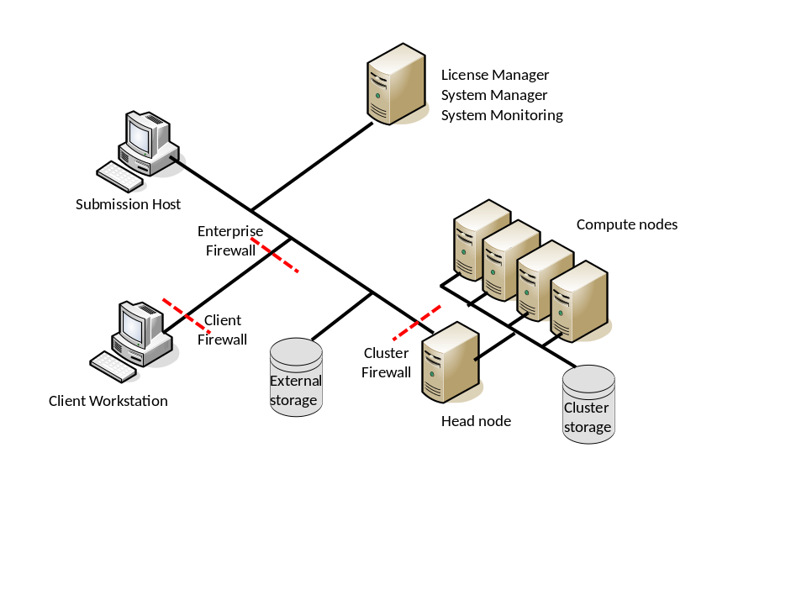

Actors
Here we define the important characteristics of the actors/players in the diagrams.

- Client workstation: The machine used by the end-user to submit, monitor and retrieve their results. A client machine can be considered to be mobile, frequently dis-connected from the network and not permanently sharing a file system with the enterprise network or the computing resource.
- Submission host: A workstation from which the user can submit and monitor jobs to the compute cluster. Generally a machine that is permanently connected to the enterprise network and able to access the corporate and cluster file systems.
- The back-end compute resource (the cluster), consisting of:
  - Head node: This is the primary contact point for submission hosts to submit work to the cluster. Possibly the only part of the compute resource visible to other network clients.
  - Compute nodes: The compute resources managed by the head node. These nodes may only be accessible from the Head node.
  - A “cluster” file system that is common between the head node and compute nodes and may be accessible from the submission host, but not the client workstation.
- External Storage: A storage resource that is accessible through authenticable network protocols (e.g. http, scp, ftp, ..) from outside the enterprise network (the client workstation) and within the enterprise network (from the submission host) and from the cluster’s head node. This is not a global file storage system.
- Network Router: Linking the workstation, submission hosts and head nodes.
- Firewall(s): One of many protecting the head node, client workstation and submission hosts.

Additional constraints
The goal in this scenario is to provide a ‘good’ user experience when the client machine is in ‘difficult’ networking environments. Specifically:
- There is no shared file system between the client workstation and the cluster’s head node. Depending on the scheduling system this may make it impossible for the client workstation to act as a submission host to the scheduler, and for the computational task to access the files located on the client workstation.
- There may be a file system between the cluster’s head node and the compute nodes.
- Many computational applications have an element of interaction with the compute nodes. In such a scenario the compute nodes need to be able to ‘connect back’ to the client workstation to provide interim results.
- Disconnected operation. It cannot be assumed that an application on the client will always be connected to the network during the complete life-cycle of any batch job. This of particular concern for long running analysis.
- Any solution must leverage the existing security mechanisms available on the client workstation and available within the enterprise. Bespoke security solutions should not be embedded within the ISV application.
- Others…

What we are not worrying about right now
In these scenarios we are realistic simplifications to provide a still useful solution. In particular:
- We are not concerning ourselves with the process by which a client application finds a compute resource. We assume that such a resource is ‘well known’ within an organization and such a resource may encapsulate other resources… but if it does such behavior is not visible to the client application.
- We are not concerned about accounting for use of the application within the scenario. The cluster’s management system will frequently have an accounting capability but this is not exposed in these scenarios.
- We are not concerned about License Managers. An application will frequently require the presence of a License Manager and its execution on the cluster may be delayed until appropriate licenses are available. In such situations this can be reflected in the state exposed by the cluster management system.
- Others…

Specification Pool
In enabling the interaction between the client and the application installed on the cluster we will use web service and related specifications developed within the Open Grid Forum and other standards bodies. These are described briefly below – further information and technical details of the specification can be found elsewhere.

WS-Addressing
The WS-Addressing specification defines an extensible XML data structure called the endpoint reference (EPR) that serves to encapsulate the information needed by a client to message a service. The EPR includes such data as a network protocol address, an extensible metadata section to convey arbitrary suggestions such as security policies, and an opaque section for session/resource identifiers, etc.

WS-Security
The Web Services Security (WS-Security) family of specifications defines a general-purpose mechanism for associating security credentials with message content which is then used to construct a set of specific profiles for encoding popular token types (e.g., X.509, Kerberos, SAML, and Username-token credentials). The WS-Security Core specification also defines the application of XML-Encryption and XML Digital Signature to provide end-to-end messaging integrity and confidentiality without the support of the underlying communication protocol. In order to achieve real-world interoperability, the WS-I BSP provides guidance on the use of WS-Security and its associated security token formats to resolve nuances and ambiguities between communicating implementations intending to leverage common security mechanisms

Job Submission Description Language (JSDL)
JSDL is an XML-based schema for describing applications, the resources required for the application (e.g., memory, number and sped of CPU’s, etc.), files to stage-in before the application executes, files to stage-out upon completion, the command line string to be executed, etc. JSDL defines terms in the job description space and encourages definition of new terms.

JSDL-SPMD

Basic Execution Service (BES)
The BES specification defines interfaces for creating, monitoring, and controlling computational entities such as UNIX or Windows processes, or parallel programs—what we call activities. Clients define activities using JSDL. A BES implementation executes each activity that it accepts. A BES resource may represent a single computer; a cluster managed through a resource manager such as Load Sharing Facility (LSF), Sun Grid Engine (SGE), Portable Batch System (PBS), Windows HPC Server 2008 (HPCS 2008) or Condor; or even another BES implementation.

HPCP-Application

HPC Basic Profile (HPCBP)
The HPCBP is a profile on BES and JSDL that supports a minimal set of capabilities to satisfy a particular use case. The set of operations does not include data staging, delegation or application deployment. As there was not an agreed upon security model at the time the document was developed, the profile includes username/token and X.509 token credential profiles from WS-I BSP (WS-I:WS-I Basic Security Profile) for authentication. The profile was written during the summer and early Fall of 2006, with an interoperability demonstration at SC’06 in Tampa with a dozen different implementations from around the world.

FS Extension of HPC-BP

Byte-IO
ByteIO provides POSIX-like read and write operations on sequences of bytes, There are two variations of this interface. In the RandomByteIO interface, the offset, number of bytes, and data buffers are passed to the operations. In the Streamable ByteIO interface, the operations do not take the offset.

Scenarios
In this section we will describe the two main motivating scenarios driving ISVs in the HTC scenarios:
- Direct job submission from a client workstation to a back-end compute cluster.
- Direct job submission from a client workstation to a back-end in which the compute nodes need to “connect” back to the client workstation, e.g. to deliver interim results.

In these scenarios we will assume:
- There is no shared file system between the client workstation and the compute cluster thereby requiring some form of file staging to take place both of input data and the final results.
- The client workstation may not have an IP address that can be accessed by the compute cluster, thereby making it impossible for the computer cluster to access a service running the client workstation that can provide/receive files from the compute cluster.
- The client workstation may not be available throughout the job’s complete life-cycle (i.e. submission, queuing and execution) as it has disconnected.

The software infrastructure to support these scenarios includes:
- Client operating system
- Cluster operating system
- Cluster’s job scheduling software (e.g. LSF, PBS, HPCS 2008, SGE)
- Application – client component
- Application – cluster component
- Client middleware – installed or incorporated into the application’s client component
- Cluster middleware – installed or incorporated into the software running on the head node
- File staging software – the network protocol(s) needed to put/get bits on the external storage

Installation and Configuration
Cluster
The cluster administrator needs to perform a one off installation and configuration of the ‘middleware’ software – the bits that glue the application, the operating system and the cluster management software together. It is assumed that the base operating system and cluster management software (e.g. PBS, LSF, HPCS 2008, SGE, etc) are already installed – administrators will resist having to change this infrastructure. This is the non-application specific software necessary to connect the client to the cluster scheduler and the application. Software from different applications will also need to be installed on cluster.

Client
The administrator of the client machine will need to install the client components of the application software and any middleware software need to support the client interactions. This software needs to install on top of the existing operating system components.

Verification
Several verification steps can be identified on both the cluster and the client machine before any of these scenarios should be attempted:
- Run the application on the cluster from the head node or submission host (without any use of the ‘middleware’):
  - On a single processor.
  - On multiple processors as part of a parallel (MPI) job.
- Upload a file from the head node to the external storage server..
- Download a file from the external storage server to the head node.
- Upload a file from a compute node to the external storage server.
  - This may not be supported by the cluster if compute nodes have no external network visibility.
- Download a file from the external storage server to a compute node.
  - This may not be supported by the cluster if compute nodes have no external network visibility.
- Upload a file from the client machine to the external storage server.
- Download a file from the external storage server to the client machine.
- That there is network connectivity from the client machine to the cluster.
- Upload a file from the client machine to the cluster’s head node.
- Download a file from the cluster’s head node to the client machine.
- The credentials provided by the user on the client machine can access the middleware services on the head node.
- The credentials provided by the user on the client machine can access and submit a job through the service on the head node to the cluster.

Running through these tests, both on installation and during use, provides the means to self-configure the client to adapt to its current network environment, and the means to trouble shoot any failures.

Direct Job Submission
With the middleware and application software installed on the client and the cluster and the connectivity between the components verified, the remote execution of the application can be initiated:

- Interaction between the local user with the client application to formulate the problem that needs to be solved on the cluster resource.
- Identification and generation of any configuration or data files needed by the application when it is executed on the remote resource.
- Selection of a cluster that is to be used to solve the problem:
  - The required application needs to be installed on the selected cluster
  - The user has the credentials to access the required application on a cluster
  - The client machine is able to contact the cluster
  - The client machine and the cluster are able to transfer files between each other or through an external storage server if required by the analysis.
- Formulation of the JSDL document using:
  - HPC Application profile if a single processor job
  - JSDL-SPMD if a multi-processor job
  - JSDL-Parameter Sweep specification if a parameter sweep job
- Uploading of the files to the designated external storage server if required.
- Submission of the JSDL document to the cluster’s HPCBP endpoint.
The client may disconnect from the network at this point with the next steps taking place asynchronously on the cluster. These are driven by the middleware on the cluster’s head node and through the underlying file system.

- Downloading of the files to the cluster from the external storage server.
- Execution of the application.
- Uploading of any output files to the designated external storage server.

The client either:
- Has remained connected to the network and recognizes through polling that the activity is complete.
- Reconnects to the network and realizes that the activities it has dispatched are complete.

Execution on the client continues:
- Retrieval of the output files from the designated external storage server to the client.
- Notification (locally) to the user that the job is complete.

There is no requirement that the client is directly addressable by the cluster or a need for a shared file system.

Direct Job Submission with interim results from the compute nodes
With the middleware and application software installed on the client and the cluster and the connectivity between the components verified, the remote execution of the application can be initiated. In this scenario the client needs to remain connected to receive interim results from the application.

- Interaction between the local user with the client application to formulate the problem that needs to be solved on the cluster resource.
- Identification and generation of any configuration or data files needed by the application when it is executed on the remote resource.
- Selection of a cluster that is to be used to solve the problem:
  - The required application needs to be installed on the selected cluster
  - The user has the credentials to access the required application on a cluster
  - The client machine is able to contact the cluster
  - The client machine and the cluster are able to transfer files between each other or through an external storage server if required by the analysis.
- Initialization of a ByteIO endpoint on the cluster’s head node.
- Formulation of the JSDL document with the ByteIO endpoint:
  - HPC Application profile if a single processor job
  - JSDL-SPMD if a multi-processor job
  - JSDL-Parameter Sweep specification if a parameter sweep job
- Uploading of the files to the designated external storage server if required.
- Submission of the JSDL document to the cluster’s HPCBP endpoint.

Activity on the cluster and on the client takes place concurrently. A two-way channel is established between the client and the running application (through the cluster’s head node) allowing the client to ‘steer’ the application and the application to deliver intermediate results back to the client.

On the cluster | On the client machine
- Downloading of the files to the cluster from the file server. | Retrieve interim results from the ByteIO endpoint and act on them.
- Initialization of the application.
- Delivery of interim results to the ByteIO endpoint on the head node.
- Completion of the application.
- Uploading of any output files to the designated file server. | Poll the activity until it is complete.

Execution on the client continues:
- Retrieval of the output files from the designated file server to the client.
- Notification (locally) to the user that the job is complete.

There is no requirement that the client is directly addressable by the cluster or a need for a shared file system. The application needs to be modified to deliver interim output to the ByteIO endpoint.

Implementation Architecture

Client

External Storage Server

Cluster’s Head Node

Application

Advice to ISV’s

Advice to Platform Providers

Open Issues In The Document (To Be Removed)

Questions that need to be answered
What are the “native” credentialing mechanism?
- Username/password
- X.509
Where are they stored and how can they be accessed and placed in the WS framework.

What web service frameworks are being used?
- Axis
- gSOAP
- WCF

What sort of credentials are used to authenticate to the back-end compute clusters?

How do ISVs expect to access these services?
- Directly by writing their own WS clients?
- Using a programmatic API? Which languages?

Or ftp/scp/http server with one time passwords call-back
OR setting up streaming sockets

Things that need to done in the document
Need to enhance with security domains/policy issue.
Fill out scenario and complicating conditions

Have the SDK debate
How does SAGA/DRMAA fit in?
What is the form of the “Globally accessible file storage”
Read out of this document to the use case workshop
OGSA session to continue discussing the updated document

